**DIGITAL CART**

In the modern world, shopping has become an essential day to day activity for most of the people.

However, their busy life style has lessened the time to do shopping. This has made them to look for quicker and easier ways to do their shopping. Some of the difficulties that people have to go through when they do shopping include having to travel a long distance without knowing the availability of the items, difficulty in finding relevant shops inside a shopping mall, forgetting to buy some items which they intended to buy. This might involve describing past variation, understanding the pattern matching mechanisms underlying observed changes, making projections of possible future change which analyzed from app users.In order to overcome the above mentioned problems a fully functional shopping mall application is proposed in this paper. It contains details about all the shops inside a mall, available items, customer wish lists and a map . Nowadays, there are several critical issues for successful clothes matching. People feel difficulty to select the exact cloth pattern of their choice. Even though if they visit more than one shop there is no guarantee that they could get an exact match.

Along with pattern matching, this system is also based on embedded technology that uses Microchip’s microcontroller. Now days purchasing and shopping at big malls is becoming a daily activity in metro cities. People purchase different items and put them in trolley. After total purchase, one needs to go to billing counter for payments. At the billing counter the cashier prepare the bill using bar code reader which is a time consuming process and results in long queues at billing counters.

We design a smart trolley that uses RFID technology. The system will be placed in all the trolleys. It will consist of a RFID reader. All the products in the mall will be equipped with RFID tags. When a person puts any products in the trolley, its code will be detected and the price of those products will be stored in memory. As we put the products, the costs will get added to total bill. The customer can also return the product from trolley, thus the cost of the item will be reduced from the bill.

With this system customer will have the information about price of every item that are scanned in, total price of the item and also brief description about the product. This system will save time of customers and manpower required in mall and cost associated with the product.

This is the site for understanding the recent drifts, quality, price, availability of the products and

more before we buy from stores of a particular Shopping mall. It also involves a Pattern matching algorithm which enhances the shopping process more useful for the customers, so that they can easily find out their products in a matter of time. .In this system we can make the task of selecting the cloth patterns easily without time consumption in just one click. Once we upload a pattern we should be able to find in which shop the uploaded pattern is available, hence it is easily to target the shop and make the purchase easily.

**SYSTEM SPECIFICATION**

**Hardware Specification**

The selection of hardware is very important in the existence and proper working of any of the software. When selecting hardware, the size and capacity requirements are also important. The hardware must suit all application developments**.**

* Processor : i3 or above.
* System Bus : 32Bit or 64Bit
* RAM : 4GB or Above
* HDD : 200 GB or Above
* Monitor : 14” LCD or Above
* Key Board : 108 Keys
* Mouse : Any Type of mouse
* Mobile : Android supported mobile phone

**Software specification**

One of the most difficult tasks is selecting software, once the system requirement is find out then we have to determine whether a particular software package fits for those system requirements. This section summarizes the application requirement.

* Operating System : Windows 8 or Above Any 32 bit or 64 bit platform
* Front End :Android,Python
* Back End :MySQL
* IDE : Eclipse or Android studio

:PyCharm

* Microcontroller :8086

**EXISTING SYSTEM**

Supermarket is the place where customers come to purchase their daily using productsand pay for that.

So there is need to calculate how many products are sold and to generate the billfor the customer.

Cashier’s desks are placed in a position to promote circulation.

At present,many supermarket chains are attempting to further reduce labor costs by shifting to self-service

check-out machines, where a single employee can oversee a group of four or five machines at

once, assisting multiple customers at a time.

**PROPOSED SYSTEM**

This application creates an automated central bill system for supermarkets and mall.

Using PID, customers no need to wait near cash counters for their bill payment.

Since their purchased product information is transferred to central billing system.

Customers can pay their bill through credit/debit cards.

The 8- microcontroller used here has the capability of receiving 8-bit data from RFID reader.

**ADMIN**

1. LOGIN- Admin can login to the cart system by using username and password.

2. STAFF REGISTRATION/MANAGE- Admin register the staff details such as name, id, dob, address, mob and email.

3. VIEW PRODUCT- Admin can view the products stored in the cart.

4. VIEW FEEDBACK- Admin can view customer feedback about the product and purchases.

5. VIEW COMPLAINT AND GIVE REPLY- Here the admin can view complaints from any customers and can provide feedback if necessary.

**STAFF**

1. LOGIN- Staff can login to the digital cart by entering username and password.

2. ADD PRODUCT TYPE- Staff adds product details such as product category etc.

3. ADD PRODUCT- Staff can add product to the store in the different section as needed.

4. VIEW STOCK AND UPDATE- Staff can view the stock and update the stock easily.

5. GENERATE BILL - Staff can generate the bill for purchased items by the customer.

6.VIEW FEEDBACK-Staff can view feedback posted by customer.

**CUSTOMER**

1. REGISTRATION- Customer can first register this app can then login.

2.LOGIN-Staff can login to the digital cart by entering username and password.

3. VIEW BILL – Customer can view bill details for the products he/she purchased.

4.VIEW PRODUCT DETAILS IN SUPERMARKET – Customer can easily view the product details in the supermarket very easily.

5.POST FEEDBACK – A customer can post feedback about the product he/she purchased.

6. POST COMPLAINT AND VIEW REPLY – The customer can post complaints for the product he/she purchased.

**Feasibility study**

A feasibility study is a preliminary study undertaken to determine and document a project's viability.

The results of this study are used to make a decision whether to proceed with the project. If it indeed leads to a project being approved, it will - before the real work of the proposed project starts - be used to ascertain the likelihood of the project's success. It is an analysis of possible alternative solutions to a problem and a recommendation on the best alternative. It, for example, can decide whether an order processing be carried out by a new system more efficiently than the previous one. The feasibility study proposes one or more conceptual solutions to the problem set for the project. The conceptual solution gives an idea of what the new system will look like. They define what will be done on the computer and what will remain manual. It also indicates what input will be needed by the system and what outputs will be produced. These solutions should be proven feasible and a preferred solution is accepted.

The feasibility study environment enables all alternatives to be discussed and evaluated. This phase starts with an identification of the main characteristics of the required system. During this stage it is important to collect information as much as possible about the software package that might meet the specification from as many sources as possible.

Normally, the central endeavor of a feasibility study is a cost benefit analysis of various alternatives. It can be defined as a systematic comparison between the cost of carrying out a service or activity and the value of that service or activity. The main benefits are qualitative than quantitative.

A feasibility study could be used to test a new working system, which could be used because:

* The current system may no longer suit its purpose,
* Technological advancement may have rendered the current system obsolete,
* The business is expanding, allowing it to cope with extra work load,
* Customers are complaining about the speed and quality of work the business provides.
* Competitors are now winning a big enough market share due to an effective integration of a computerized system.

When a new project is proposed, it normally goes through feasibility assessment.  Feasibility study is carried out to determine whether the proposed system is possible to develop with available resources and what should be the cost consideration.

Facts considered in the feasibility analysis were

* **Technical Feasibility**
* **Operational Feasibility**
* **Economic Feasibility**

**3.5 .Technical Feasibility**

This involves questions such as whether the technology needed for the system exists, how difficult it will be to build, and whether the firm has enough experience using that technology. The assessment is based on an outline design of system requirements in terms of Input, Output, Fields, Programs, and Procedures. This can be qualified in terms of volumes of data, trends, frequency of updating etc. in order to give an introduction to the technical system.

The system requires normal configuration computer system that are commonly available. The software requirements are C# .Net, Windows 8 or higher versions of OS. Thus proposed system is technically feasible.

**3.5. Operational Feasibility**

This analysis involves how it will work when it is installed and the assessment of political and managerial environment in which it is implemented. People are inherently resistant to change and computers have been known to facilitate change. The new proposed system is very much useful to the users and there for it ill accept broad audience.

The proposed system offers:

* Greater user friendliness
* Better output which can be easily interpreted.
* Higher speed.
* Meets the requirements of the organizations.

**3.5. Economic feasibility**

This involves questions such as whether the firm can afford to build the system, whether its benefits should substantially exceed its costs, and whether the project has higher priority and profits than other projects that might use the same resources. This also includes whether the project is in the condition to fulfill all the eligibility criteria and the responsibility of both sides in case there are two parties involved in performing any project.

This study presents tangible and intangible benefits from the project by comparing the developments and operational costs. The technique of cost benefit analysis is often used as a basis for assessing economic feasibility. This system needs some more initial investment than the existing system, but it can be justifiable that it will improve the quality of service.

Thus feasibility study should center along the following points:

* Improvement resulting over the existing method in terms of accuracy, timeliness.
* Cost comparison.
* Estimate on the life expectancy of the hardware.
* Overall objective

**3.6. Project Planning And Scheduling**

For the successful completion of the every project there must be detailed scheduling. The software development has different participating steps. First of all, I had done the requirement analysis phase. For this I visit different sites that offer resume writing helps, visits different websites, and I discuss with my friends and project guide. After collecting the requirements a detailed study of preliminary investigation is done. After the analysis phase the requirements and document design is divided into modules. The document is created, which includes dataflow diagrams, ER diagrams etc.

As next step the actual development of the system takes place. The design representations are translated into codes. Documentation of codes is done by providing explanations of how procedures are used. Documentation is essential to test the program and carry on maintenance once the application has been installed.

As next step testing is done. After a system has been developed it is very important to check if it fulfils the user requirements. Implementation of the system means putting up system on user’s side. Like any system there is an aging process. Therefore the system requires periodic maintenance for software or hardware.

**3.7 Software Requirements Specification**

A software requirements specification (SRS) is a description of a software system to be developed, laying out functional and non-functional requirements. (Non-functional requirements impose constraints on the design or implementation such as performance engineering requirements, quality standards, or design constraints.) The specification may include a set of use cases that describe interactions the users will have with the software. The software requirements specification document enlists enough and necessary requirements that are required for the project development. To derive the requirements we need to have clear and thorough understanding of the

Products to be developed or being developed. This is achieved and refined with detailed and continuous communications with the project team and customer till the completion of the software.

**The Front End**

An Integrated Development Environment (IDE) (also known as Integrated Design Environment or Integrated Debugging Environment) is a software application that provides comprehensive facilities to computer programmers for software development. An IDE normally consists of:

* A source code editor
* A compiler and/or an interpreter
* Build automation tools
* A debugger

**PYTHON**

[Python](https://www.geeksforgeeks.org/python-programming-language/) is a widely used general-purpose, high level programming language. It was initially designed by Guido van Rossum in 1991 and developed by Python Software Foundation. It was mainly developed for emphasis on code readability, and its syntax allows programmers to express concepts in fewer lines of code.

Python is a programming language that lets you work quickly and integrate systems more efficiently.

There are two major Python versions- **Python 2 and Python 3**. Both are quite different.

**HTML**

Hypertext Markup Language (HTML) is the standard markup language for creating web pages and web applications. With Cascading Style Sheets (CSS) and JavaScript it forms a triad of cornerstone technologies for the World Wide Web. Web browsers receive HTML documents from a web server or from local storage and render them into multimedia web pages. HTML describes the structure of a web page semantically and originally included cues for the appearance of the document.

**Eclipse IDE**

Google provides an integrated development environment (IDEs) to develop new applications. The *Android Developer Tools* (ADT) are based on the Eclipse IDE. ADT is a set of components (plug-ins), which extend the Eclipse IDE with Android development capabilities. Eclipse is an integrated development environment (IDE).it contains a base workspace and an extensible plug-in system for customizing the environment. It is written mostly in java. Eclipse can be used to develop applications. Eclipse sometimes performs multiple commands within a single connection to the server. This may cause problems with servers that are servers that are running server scripts in response to certain commands.Eclipse IDE contains all required functionality to create, compile, debug and deploy Android applications. This also allows the developer to create and start virtual Android devices for testing. Both tools provide specialized editors for Android specific files. Most of Android's configuration files are based on XML. In this case these editors allow you to switch between the XML representation of the file and a structured user interface for entering the data. Eclipse uses plug-ins to provide all the functionality within and on top of the runtime system.

The plug-in architecture supports writing any desired extension to the environment, such as for configuration management. Java and CVS support is provided in the Eclipse SDK, with support for other version control systems provided by third-party plug-ins. The Eclipse SDK includes the Eclipse Java development tools (JDT), offering an IDE with a built-in incremental Java compiler and a full model of the Java source files. This allows for advanced refactoring techniques and code analysis. The IDE also makes use of a workspace, in this case a set of metadata over a flat filespace allowing external file modifications as long as the corresponding workspace "resource" is refreshed afterwards. Eclipse implements use the graphical control elements of the Java toolkit called SWT, whereas most Java applications use the Java standard Abstract Window Toolkit (AWT) or Swing. Eclipse's user interface also uses an intermediate graphical user interface layer called JFace, which simplifies the construction of applications based on SWT. Eclipse was made to run on Wayland during a GSoC-Project in 2014.

**The Back End**

**Database Servers**

A database server is used to store data in a database. Users can access the data and manipulate it. There are many types of databases. The most popular among them is the Relational Database Management System (RDBMS).

**RDBMS**

RDBMS is a type of database management system that stores data in the form of related tables. Relational database are powerful because they require few assumptions about how data is related or how it will be extracted from the database. As a result, the same database can be viewed in many different ways. An important feature of relational systems is that a single database can be spread across several tables. This differs from flat-file database, in which each database is self-contained in a single table.

**My SQL**

MySQL is an open source relational database and it includes advanced data types. MySQL operates using client/server architecture in which the server runs on the machine containing the database and client connect to the server over the network. MySQL run on all platforms supported by MySQL and provides the most direct means of interacting with the server, so it’s the logical client to begin with.

* You need to have the MySQL software installed.
* You need a MySQL account so that you can connect to the server.
* You need a database to work with.

The required software includes the MySQL clients and a MySQL clients and a MySQL server. The client program must be located on the machine where you will working. The server can be located on our machine although that is not required. As long as you have permission to connect to it the server can be located anywhere. In addition to the MySQL software you will need a MySQL account so that the server will allow you to connect and create us sample database and its table.

**SYSTEM DESIGN**

Design is the first step in the development phase for every engineered product or system. Computer software designing techniques like engineering design approaches in the other disciplines, changes continuously as new methods, better analysis and broader understanding evolve.

System design involves translating information requirements and conceptual design into technical specification and general flow of processing. After the user requirements are identified, related information is gathered to verify the problem and after evaluating the existing system, a new system is proposed. The proposed system consist of various tables, their maintenance and report generation.

**4.1 Users of the System**

This website uses admin.The android part is used by the user. To be a user must register one time in this Android part. The user gets their user name and password at the time of registration and they should use this username and password for further.

**4.2 Modularity Criteria**

**Module Design**

**Admin**:The admin can log in to the website using a unique username and a password. Admin can view alerts from device and it can manage emergency numbers. And the admin can also view the complaints of users and post the reply.

**Users**: User can log on to the android section using their username and password. And he/she can manage events,set friends,send alert to friends.They can also set remainder and call emergency number.

**INPUT DESIGN**

Input design is part of overall system design, which requires careful attention. The major objectives of input design are to make the data entry easier logical and error free. With this objective the screen for the system are developed. The input design requirement such as user friendliness, consistent formal and interactive dialog boxes for giving the right message and help for the user at the right time are also considered for the development of the project. The decisions made during the input design are:

* To provide cost effective method of input
* To achieve the highest possible level of accuracy
* To ensure that the input is understood by the user

The input type involves converting the user-originated inputs into a computer-based format. The aim of the computer design is to make the data entry easier, logical error free. It helps us to filler errors in the input data that otherwise entered into the database might have brought in a lot of inconsistency.

Alert for wrong entries such as primary key duplication, letters in numeric data, wrong data format, range exceed have been provided in the application. Upon this, a well-documented instruction set has been provided for the non-frequent and first-time users to familiarize them with our web site.

Maximum care has been taken to ensure that users type in only minimum data into the system, as all he or she will have to do is to move and click the mouse or strike a key to select the desired data at the desired position.

The input design is the link between the information system and the user. It comprises developing specification and procedures for data preparation and those steps that are necessary to put input data into a usable form for processing data entry. Instructing the computer to read data from a written or a printed document can achieve the activity of putting data into the computer for processing or it can occur by having people key data directly into the system. The design of inputs focuses on controlling the amount of inputs required, controlling errors, avoiding delay, avoiding extra steps and keeping the process simple.

**OUTPUT DESIGN**

Output design generally refers to the results and information that are generated by the system. For many end-users, output is the main reason for developing the system and the basis on which they evaluate the usefulness of application.

The objective of a system finds its shape in terms of the output. The analysis of the objective of a system leads to determination of outputs. Outputs of a system can take various forms. The most common are reports, screens displays, printed form, graphical drawing etc. the output also vary in terms of their contents, frequency, timing and format. The users of the output, its purpose and sequence of details to be printed are all considered. The output from a system is the justification for its existence. If the outputs are inadequate in any way, the system itself is inadequate.

Output design phase of the system is concerned with the convergence of information to the end user-friendly manner. The output design should be efficient, intelligible so that system relationship with the end user is improved and their by enhancing the process of decision-making.

Output Types:

* External Outputs, whose destination is outside the organization and is the main image of the organization.
* Internal Outputs, whose destination is within the organization and which require careful design because it is user’s main interface with the computer.

Operational Outputs, whose use is purely within the computer departments.

* Interactive outputs, which involve the user in communicating directly with the computer.

**4.3.1 Data Flow Diagrams:**

A data flow diagram (DFD) or a bubble chart is a graphical tool for structured analysis. DFD models a system by using external entities from which data flow to a process, which transforms the data and creates output data flows which go other process or external entities or files. Data in files may also flow to processes as inputs.

DFDs can be hierarchically organized, which help in partitioning and analyzing large systems. As a first step, one dataflow diagram can depict an entire system which gives the system overview. It is called context diagram of level0 DFD. The context diagram can be further expanded.

The successive expansion of a DFD from the context diagram to those giving more details is known as leveling of DFD. Thus a top down approach is used, starting with an overview and then working out the details. The main merit of the DFD is that it can provide an overview of what data a system would process, what transformation of data are done, what files are used, and where the results flow.

**DFD Design Notation**

In DFD, there are four main symbols:-

Source or Destination of Data

Process

Flow of data

Process Transforming Data

Temporary Repository of Data

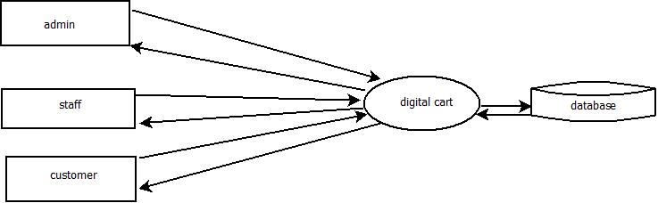

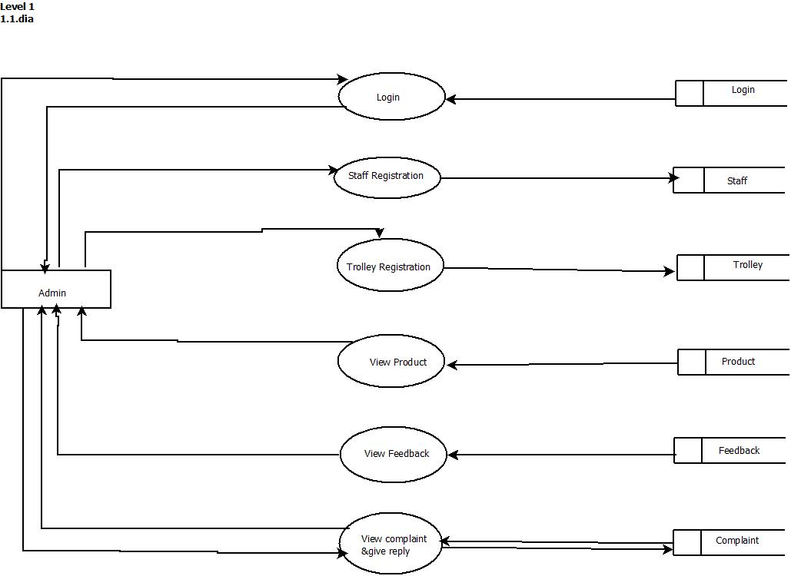

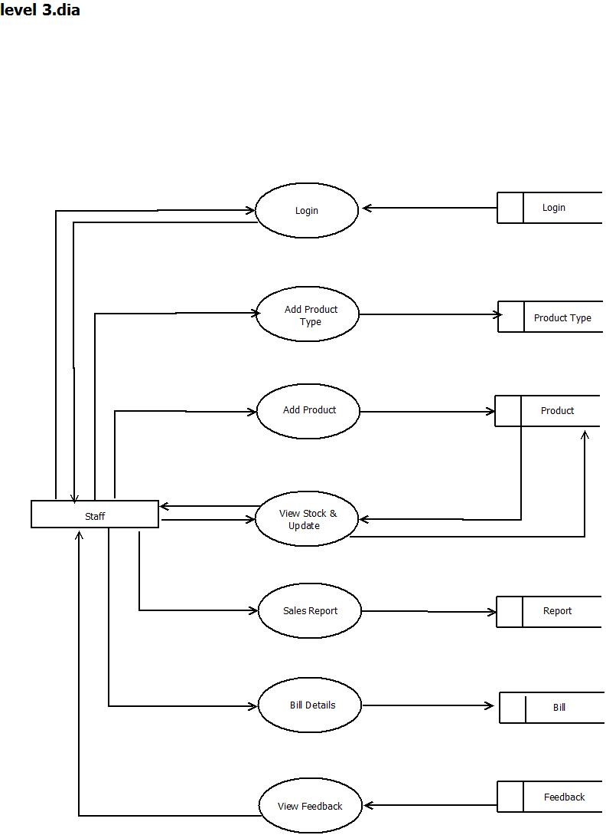

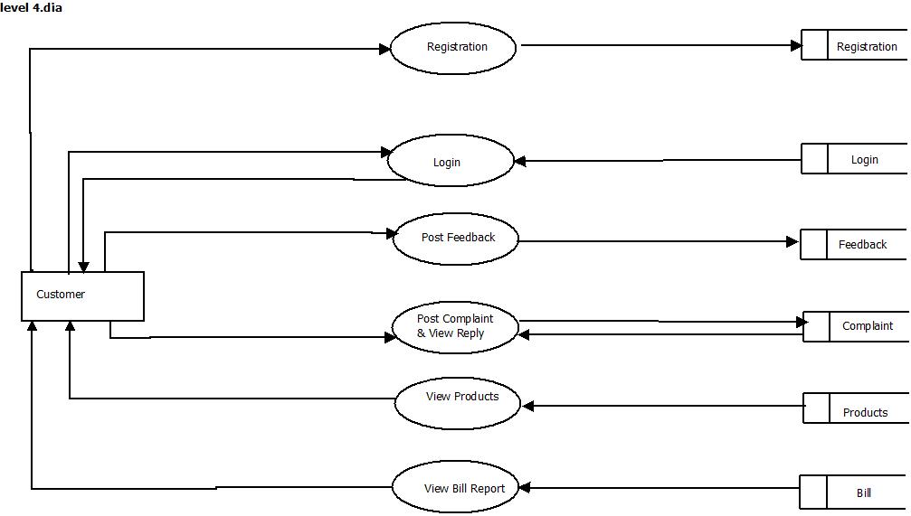

**4.4 Database Design**

Database design is the process of producing a detailed data model of a database. This logical data model contains all the needed logical and physical design choices and physical storage parameters needed to generate a design in a data definition language, which can then be used to create a database. The term database design can be used to describe many different parts of the design of an overall database system. Principally, and most correctly, it can be thought of as the logical design of the base data structures used to store the data. In the relational model these are the tables and views. In an object database the entities and relationships map directly to object classes and named relationships. However, the term database design could also be used to apply to the overall process of designing, not just the base data structures, but also the forms and queries used as part of the overall database application within the database management system.The process of doing database design generally consists of a number of steps which will be carried out by the database designer.

Usually, the designer must:

* Determine the relationships between the different data elements.
* Superimpose a logical structure upon the data on the basis of these relationships

**Normalization**

Normalization is the process of decomposing a set of relations with anomalies to produce smaller and well-structured relations that contain minimum redundancy. It is a formal process of deciding which attributes should be grouped together in a relation.

**First Normal Form:** First normal form does not allow multi valued and composite valued attributes. It states that the domain of an attribute must include only atomic values and that value of any attribute in a tuple must be single value from the domain of that attribute.

**Second Normal Form:** In second normal form, for relations where primary key constrains multiple attributes, non-key attributes should not be functionally dependent on a part of the primary key.

**Third Normal Form:** In third normal form it satisfies the second normal form and no non-key attributes of relation transitively dependent on primary key.

**LIST OF ENTITIES AND ATTRIBUTES**

**ADD ENTITIES AND ATTRIBUTES**

**Entity Relationship Diagram Notations**

**Entity:**

An entity is an object or concept about which you want to store information.

Entity

**Attribute:**

Each entity has attributes, or particular properties that describe the entity.

Attribute

**Key attribute :**

A key attribute is the unique, distinguishing characteristic of the entity.

keyAttribute

**Relationships:**

Relationships illustrate how two entities share information in the database structure.

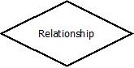

The ER diagram used in this project is given below:

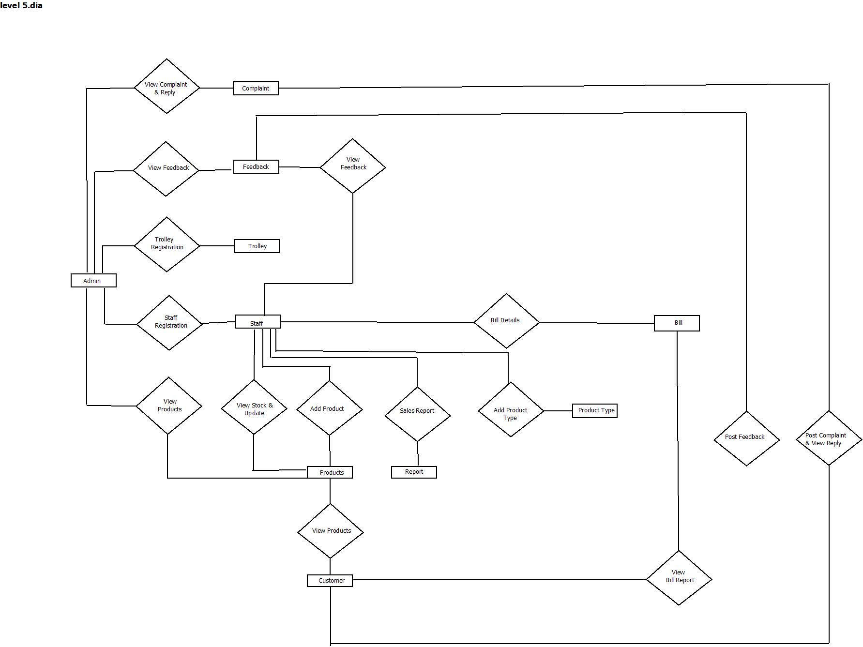

**ADD ER**

**STRUCTUREOFTABLES**



















**UML Diagrams**

**7.1.1.1 Use Case Diagram**

Admin module

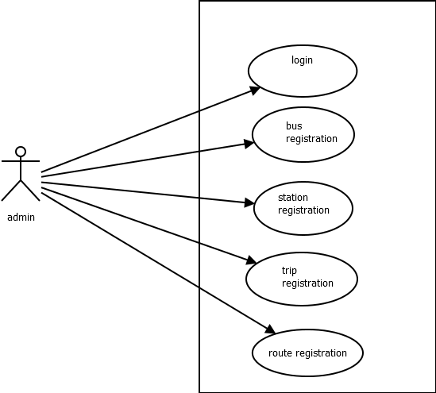

Busmodule

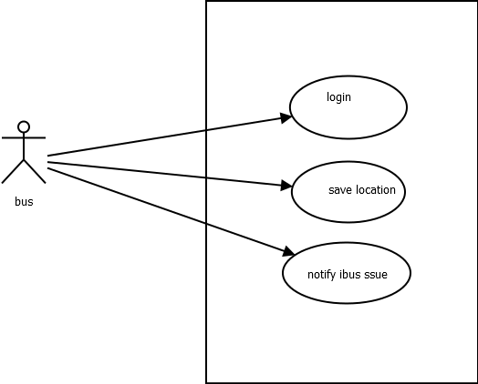

User module

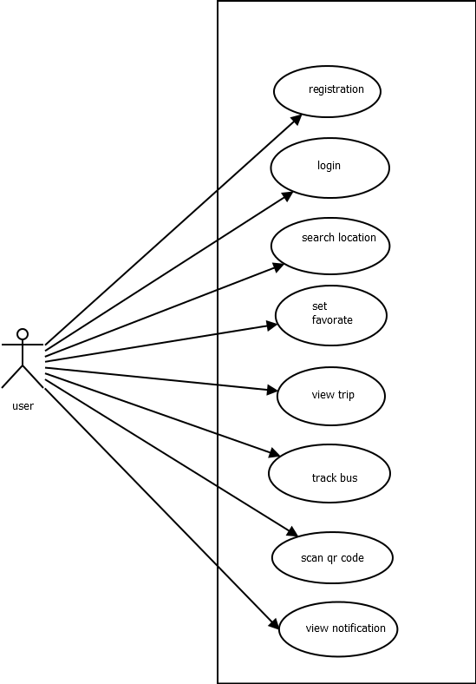

**IMPLEMENTATION**

Implementation of the system refers to the final installing of the package in its real environment , to the satisfaction of the indeed users and the operation of the system. It is the process of converting a new or revised system design to operation. It is the key stage in achieving successful new system. The process of putting the developed system in actual use is called system implementation. This includes all those activities that take place to convert from the old system to new system. It must therefore be carefully planned and controlled. Proper guidance should be imparted to the users so that he is comfortable in using the application.

**Implementation Plan**

The transformation from theoretical designs to working system is done in this stage. Developed package of system is tested with simple data, accurate error identification and then through proposed change from the user etc. a dress rehearsal working of system is done, so as the system is scrutinized, for pointing out errors and modifications required if any keeping in mind the expectations and specifications from the system.

**Education And Training**

The expectations from the system are made achieved by the people who will be involved to be confident of their role in the new system. The complexity of the system is directly proportional to the amount of training and education given for the user .Education is different from the training, as the user through education can be a part of development of the system. Education has the capability to make training more interesting and important contributions in the system changes.

Training just means to give user specific skills in order to meet their new job requirements. The role of system analyst in training will make it more understandable and effective. Training provides a better overview of new system and its present objectives.

**Training Of Application Software**

Awareness about the new system is made to the users through training, and with the underlying philosophy of the system (screen design, flow, error types during inputs, validation checks etc.) application use the system, as the users of the system may be of at different levels of hierarchy.

**Post Implementation Review**

System performance v/s expected requirements are evaluated. The implementation problems if any is taken seriously and taken care of along with admiring the achievements, failures etc. The works done here are used to improve the efficiency and user friendliness of the system.

**Security**

System security is a branch of technology known as information security as applied to computers and networks. The objective of system security includes protection of information and property from theft, corruption, or natural disaster, while allowing the information and property to remain accessible and productive to its intended users. The term system security, means the collective processes and mechanisms by which sensitive and valuable information and services are protected from publication, tempering or collapse by unauthorized activities or untrustworthy individuals and unplanned events respectively. The technologies of system security are based on logic. As security is not necessarily the primary goal of most computer applications, designing a program with security in mind often imposes restrictions on that program’s behavior.

**Maintenance**

Maintenance is making adaptation of the software for external changes (requirements changes or enhancements) and internal changes (fixing bugs). When changes are made during the maintenance phase all preceding steps of the model must be revisited.

There are three types of maintenance:

1. Corrective(Fixing bugs/errors)
2. Adaptive(Updates due to environment changes)
3. Perfective(Enhancements, requirements changes

Maintenance is enigma of the system development. The definition of the software maintenance can be given describing four activities that are undertaken after the program is released for use.

The maintenance activity occurs since it is unreasonable to assume that software testing will uncover all in a large system. The second activity that contributes the definition of maintenance occurs since rapid changes are encountered in every aspects of computing. The third activity involves recommendation for new capabilities, modification to the existing functions and general enhancements when the software is used. The fourth maintenance activity occurs when software is changed to improve future maintainability or reliability.

**TESTING**

Software testing is an investigation conducted to provide stakeholders with information about the quality of the product or service under test. Software testing can also provide an objective, independent view of the software to allow the business to appreciate and understand the risks of software implementation. Test techniques include, but are not limited to, the process of executing a program or application with the intent of finding software bugs (errors or other defects).

Software testing can be stated as the process of validating and verifying that a software program/application/product:

1. meets the requirements that guided its design and development;
2. works as expected; and
3. Can be implemented with the same characteristics.

Software testing, depending on the testing method employed, can be implemented at any time in the development process. However, most of the test effort occurs after the requirements have been defined and the coding process has been completed. As such, the methodology of the test is governed by the software development methodology adopted.

Different software development models will focus the test effort at different points in the development process. Newer development models, such as Agile, often employ test driven development and place an increased portion of the testing in the hands of the developer, before it reaches a formal team of testers. In a more traditional model, most of the test execution occurs after the requirements have been defined and the coding process has been completed.

Testing can never completely identify all the defects within software. Instead, it furnishes a criticism or comparison that compares the state and behavior of the product against oracles—principles or mechanisms by which someone might recognize a problem. These oracles may include (but are not limited to) specifications, contracts, comparable products, past versions of the same product, inferences about intended or expected purpose, user or customer expectations, relevant standards, applicable laws, or other criteria.

Every software product has a target audience. For example, the audience for video game software is completely different from banking software. Therefore, when an organization develops or otherwise invests in a software product, it can assess whether the software product will be acceptable to its end users, its target audience, its purchasers, and other stakeholders. Software testing is the process of attempting to make this assessment.

**Unit Testing**

Unit testing is a test of a simple piece of code – in our case a subroutine, a function, an event. In formal terms it is the smallest piece of code testable. It is the testing of each module and the integration of the overall system is done. Unit testing becomes verification, an effort on the smallest unit of software in the module. This is known as “Module testing”. Component-level testing is the next level up from unit testing. A component can have fairly straight forward functionality, but it is just complex enough to warrant breaking down the actual implementation into several smaller units. In this mode of testing each and every input and output form was been tested in order to check whether they could run successfully. The software worked as expected and no bug had blocked the execution of the test. Distinct outputs were generated for each input. Incorrect output was easily identified. Internal errors were automatically detected through self testing mechanism.

**Integration Testing**

Integration testing is a systematic testing that can be done with sample data. The need for the integration test is to find the overall system performance. The process of combining multiple modules systematically for conducting tests in order to find errors in the interface between modules is called ‘integration testing’. Integration testing is done after successful completion of unit testing.

The major form in this project is the registration of a third party to the site where he/she can add properties as well as edit the properties. Only the registered third parties can logon to the site, ie every registered third party’s are given a user id and password for login. If the provided user id and password by the third party is correct they can logon to their page where they can add the properties as well as edit their properties.

**Validation Testing**

Validation testing can be defined as many, but a single definition is that validation succeeds when the software functions in a manner that can be reasonable excepted by the customer. After validation test have been conducted one of the two possible conditions exists.

The function or performance characteristics are acceptable and confirmed to specification. A decision from specification is uncovered and defining list is created. System validation checks the quality of software in both simulated and live environment. First the software goes through a phase in which errors and failures based on simulated user requirements are verified and studied. All the validations of this project are working successfully.

**User Acceptance Testing**

User acceptance of a system is the key factor for the success of any system. The system under consideration was tested for user acceptance by constantly keeping in touch with required. After the developers complete the system testing successfully user acceptance testing is done at the customer end. It is the customer or the end user who knows the designs of the test cases. In this type of testing emphasis is on the usability of the product. Acceptance testing is supported through alpha and beta testing.

Alpha testing is done when the software is made operational for the first time to be tested by the users at developer’s site. Hence it is possible that it will involve making lot of changes to program code. Beta testing follows alpha testing but now the testing is done at the customer’s site that validates the product after using it for few days. At this stage few changes as compared to alpha testing would be made to the product.Here a third party was allowed to run this project. He could run this project by himself without any help from others, because the graphical user interface of this project was very much user friendly.

**Black Box Testing**

Although tests are designed to uncover errors, they are also used to demonstrate that the software functions

are operational, input is properly accepted and output is correctly produced and that the integrity of external

information is maintained. A black box test examines some of fundamental aspects of a system with little regard for the internal logical structure of the software.

All input screens were thoroughly tested for data validity and smoothness of data entry operations. Test cases were so formulated to verify whether the system works properly in rare conditions also. Error conditions were checked. Data entry operations are to be user friendly and smooth. Care was taken to make data entry as smooth as possible. Flow of object was made convenient to the data entry operations.

**White Box Testing**

It is a test case design method that uses the control structure of the procedural design to drive test cases. Using white box testing methods it was guaranteed that most of the independent paths within modules had been exercised at least once, all logical decision on their true and false sides, executed all loops at their boundaries and exercised internal data structures to ensure their data validity. All codes in my project were successfully checked for errors and ensured that therewere no errors.